21.64: a) The magnitude of the field the due to each charge is
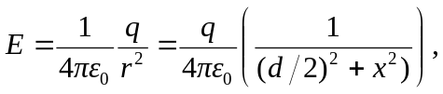
where is the distance between the two charges. The x-components of the forces due to the two charges are equal and oppositely directed and so cancel each other. The two fields have equal y-components, so:
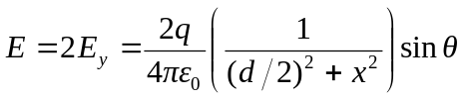
where is the angle below the x-axis for both fields.
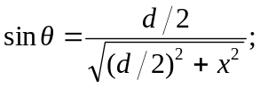
thus
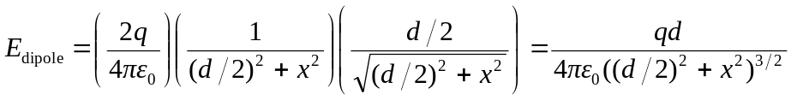
The field is the 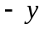directions.

b) At large 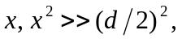 so the relationship reduces to the approximations
